# Homework 3

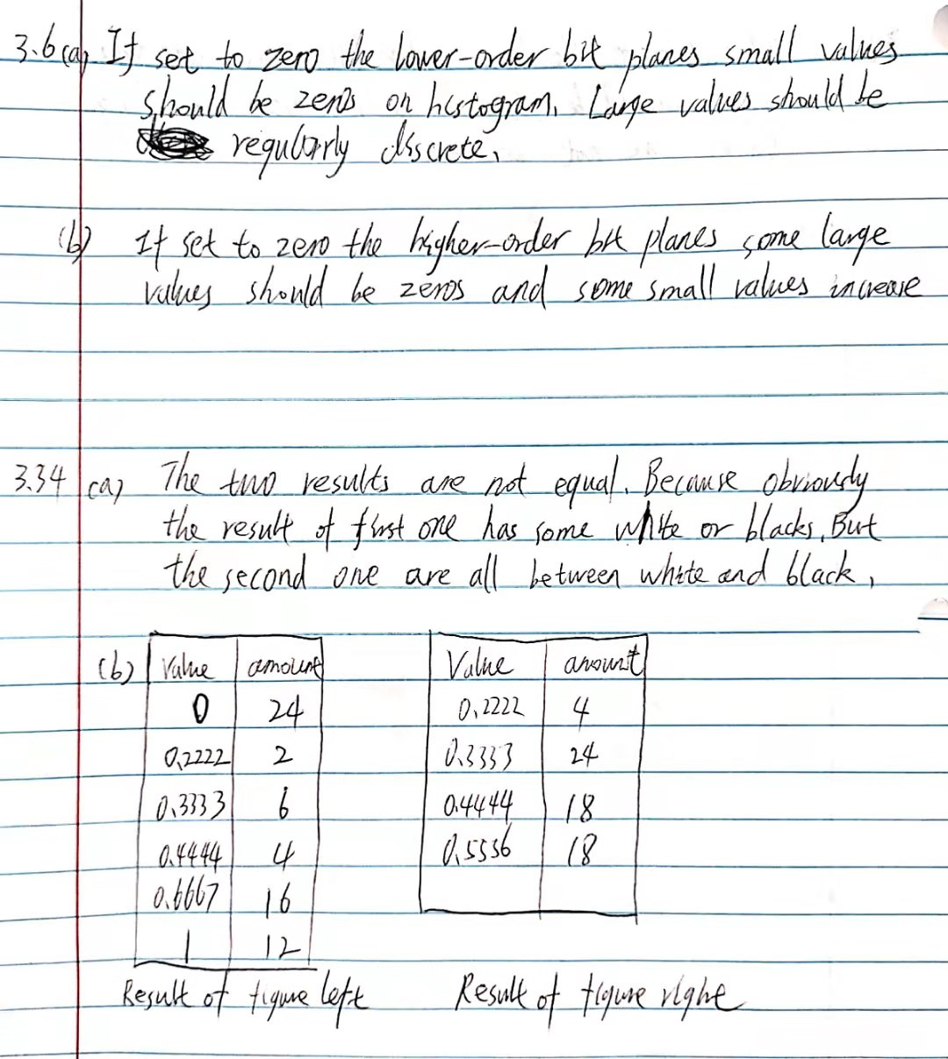

Function explanation:

Function myLaplacian() receives a grayscale image stored in a matrix and return a sharped image. Its main method is to create a matrix of every location in the kernel and make it match the location of result image. For example, the top left location (1,1) is 0 when calculate (1,2) in result image, so its matrix (1,2) is 0. Obviously, (2,2)’s matrix is image itself. Then we just multiply corresponding paraments and add them together to get Laplacian result. And add it to the original image to get final result.

Function myUnsharp() receives a grayscale image stored in a matrix and return a sharped image. Firstly, I do a zero padding according to the filter size. Then I use a double loop to calculate the value of each pixel in mean filter result. The original image minus mean result to get the mask. Mask is multiplied by k and added to the original image to get final result.

Results:

Both Laplacian and Unsharp perform well when sharping a blurry image. Results are obviously more clear and the edges are highlighted.

## Flower.pgm

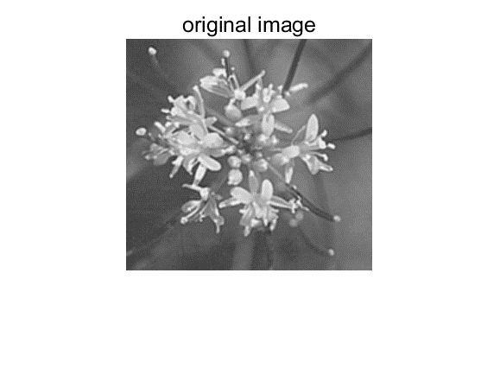

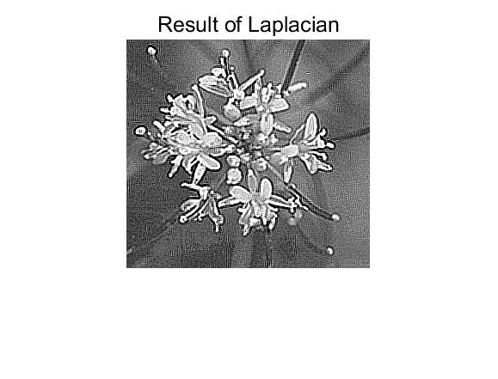

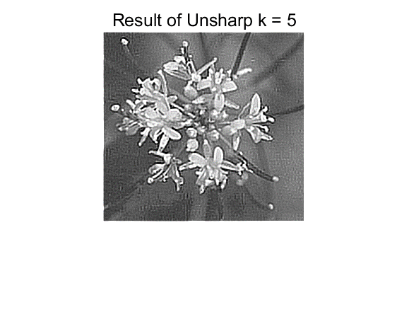

## Swan.pgm:

## Tools.pgm:



